COMHAIRLE CHONTAE AN LONGFOIRT

LONGFORD COUNTY COUNCIL

Corporate Affairs,
Aras an Chontae,
LONGFOIRT.

8th April 2015.

Chuig: Gach Ball don Chomhairle.

A Chomhairleoir,

The Monthly Meeting of Longford County Council which was due to take place on Wednesday, 8th April 2015 was adjourned as a mark of respect to Councillor Paraic Brady on the death of his Mother, Elizabeth Brady, R.I.P.

The Adjourned April Meeting of the Council will take place on Wednesday, 15th April 2015 at 4.00 p.m. in the Council Chamber, Aras an Chontae.

Mise le meas,
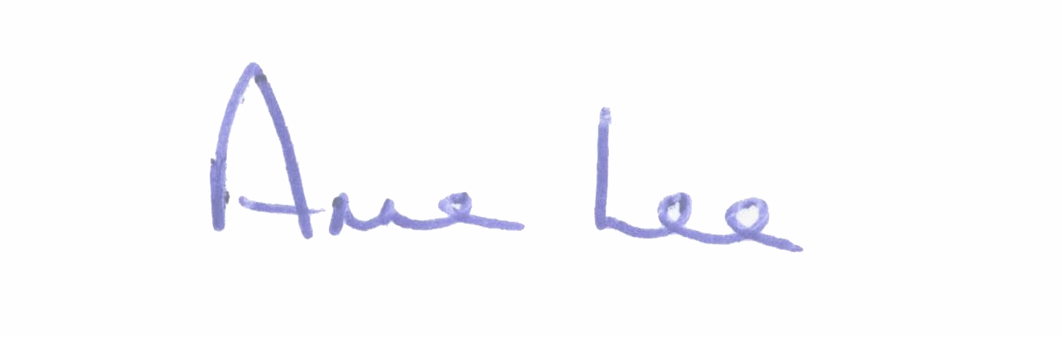

________________________
Anne Lee,
Meetings Administrator.

